**Reindeer Rice Krispies**

[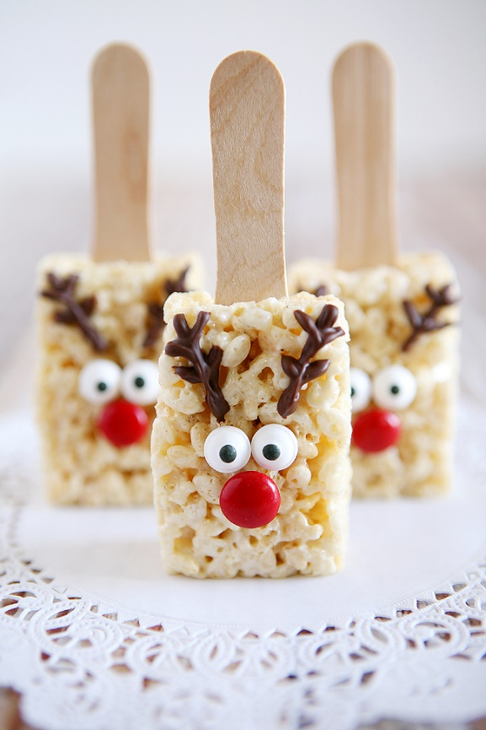](http://eighteen25.com/wp-content/uploads/2016/11/reindeer-rice-krispy-treats.jpg)Pretty much the cutest dessert recipe for the holidays you’ll ever see- **Reindeer Rice Krispies**!

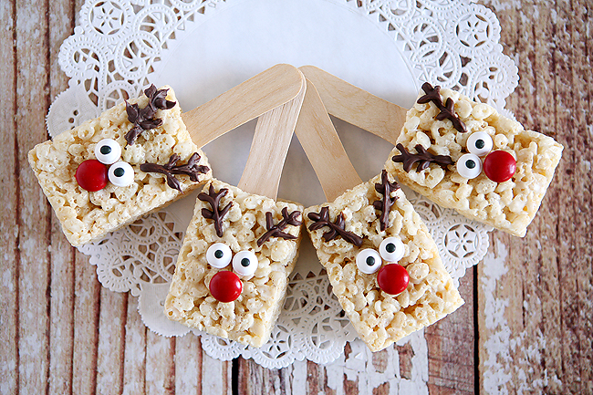

[Save](http://pinterest.com/pin/create/bookmarklet/?media=https://www.thirtyhandmadedays.com/wp-content/uploads/2016/11/reindeerricekrispies.png&url=https://www.thirtyhandmadedays.com/reindeer-rice-krispies/&is_video=false&description=Reindeer%20Rice%20Krispie%20Treats%20-%20these%20are%20the%20sweetest%20for%20the%20holidays!%20So%20cute%20and%20easy%20to%20make.%20)

Here’s what you’ll need:

* [Rice Krispies Treats](http://amzn.to/2gvg8JO) – Recipe on following page
* [Candy Eyeballs](http://amzn.to/2gve0Sq)
* [Red M&M’s](http://amzn.to/2gvdYts) or other red candy
* [Dark Cocoa Candy Melts](http://amzn.to/2gQfzbJ)
* [Craft Spoons](http://amzn.to/2gv9mUq) – or just regular popsicle sticks

**Assemble/Decorate the Rice Krispie Treats:**

Carefully push your craft spoons into the treats.

Melt your chocolate following the instructions on the package and then spoon it into a plastic baggie. Cut a small hole in the corner of your bag and you’ll be ready to make the antlers. Also use a small dot of chocolate under the candy eyes and m&m nose to attach them to the Rice Krispies Treat.

So super simple, but so super cute! If you wanted to you could package them up individually in cellophane bags and tie some bakers twine around them. Or just stand them all up and serve them on a platter or cake plate. They’ll be super cute for holiday parties or just a fun Christmas movie night with your family.

***Rice Krispies Treat Original Recipe***

Ingredients:

[Save](http://pinterest.com/pin/create/bookmarklet/?media=https://www.thirtyhandmadedays.com/wp-content/uploads/2016/11/reindeerricekrispies.png&url=https://www.thirtyhandmadedays.com/reindeer-rice-krispies/&is_video=false&description=Reindeer%20Rice%20Krispie%20Treats%20-%20these%20are%20the%20sweetest%20for%20the%20holidays!%20So%20cute%20and%20easy%20to%20make.%20)

* 3 tablespoons butter
* 1 package (10 oz., about 40) JET-PUFFED Marshmallows
* -- OR --
* 4 cups JET-PUFFED Miniature Marshmallows
* 6 cups Kellogg's® Rice Krispies® cereal

Directions

1. In large saucepan melt butter over low heat. Add marshmallows and stir until completely melted. Remove from heat.
2. Add KELLOGG'S RICE KRISPIES cereal. Stir until well coated.
3. Using buttered spatula or wax paper evenly press mixture into 13 x 9 x 2-inch pan coated with cooking spray. Cool. Cut into 2-inch squares. Best if served the same day.  
     
     
   MICROWAVE DIRECTIONS:  
   In microwave-safe bowl heat butter and marshmallows on HIGH for 3 minutes, stirring after 2 minutes. Stir until smooth. Follow steps 2 and 3 above. Microwave cooking times may vary.  
     
     
   Note  
     
   -For best results, use fresh marshmallows.  
   -1 jar (7 oz.) marshmallow crème can be substituted for marshmallows.  
   -Diet, reduced calorie or tub margarine is not recommended.  
   -Store no more than two days at room temperature in airtight container.  
   -To freeze, place in layers separated by wax paper in airtight container. Freeze for up to 6 weeks. Let stand at room temperature for 15 minutes before serving.